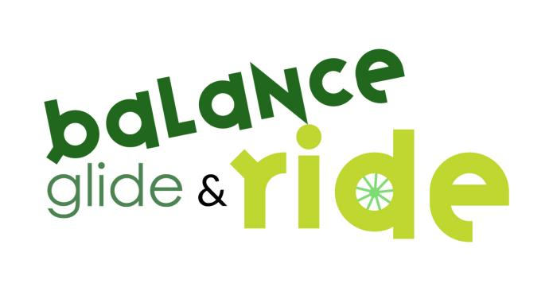

We are very excited to be delivering Balance, Glide and Ride Sessions in your child’s school on the following dates - 3rd to 7th February 2025.

To give you some more information, these sessions will involve the children learning to ride bikes without the use of stabilisers. They will either be learning to ride from a balance bike moving to a pedal bike, or if they can already pedal freely, then we will work on improving their riding skills, even adding in some Level 1 Bikeability skills.

The sessions will be approx. 40 minutes per day, every day, for the week.

Things to consider:-

- Coats and Gloves - we will continue in rain if it is not too heavy, and when it is cold, so please provide coats, and gloves are important as little hands get cold on the handlebars. Cycling type gloves in the warmer months are also a good idea to protect hands.
- Jogging bottoms/trousers are preferable than skirts/dresses when cycling as they can get caught in the wheels and also uncomfortable when sitting on the saddle. An alternative is to put on PE shorts under dresses/skirts.
- Shoes - Trainers, PE shoes, or sturdy school shoes are suitable. Not suitable are wellington boots, slip on shoes or sandals.
- Helmets - we will provide helmets but if your child would prefer to wear their own, then please feel free to bring to school (with their name in).
- Bikes - we shall provide a selection of balance and pedal bikes.
- Hair - if tying hair up, please do low pigtail/pony tails and not high ones on tops of heads, or use hair bands or large bows, otherwise helmets do not fit.
- Earrings - please remember to remove all earrings, as in PE, as the helmet straps fit close to the ears.

We look forward to meeting your child soon

The Team
Supported by Rushmoor Borough Council

(Check us out on the social media below to get an idea of what we do)
Facebook: balance glide and ride rushmoor
Instagram: @balance_glide_and_ride

